Home

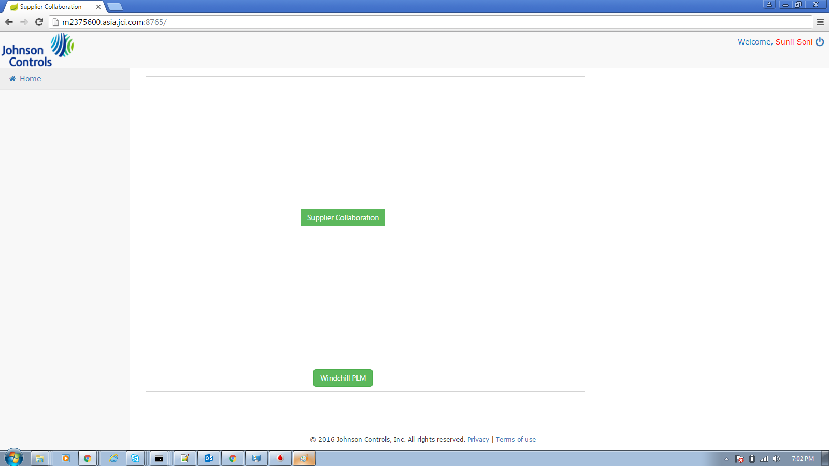

Supplier Collaboration

PO Dashboard(Graph)

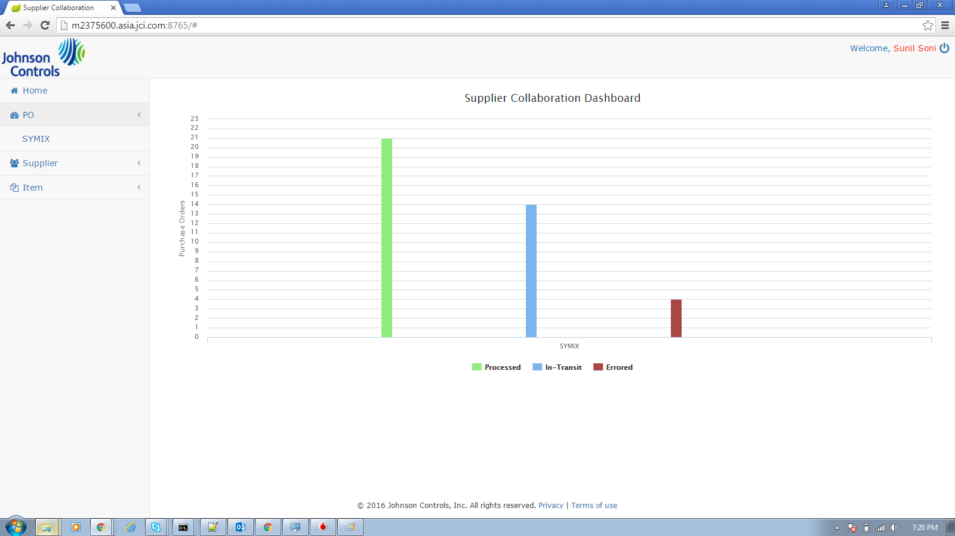

PO Grid With Process Error Grid(ErrorCount > 0)

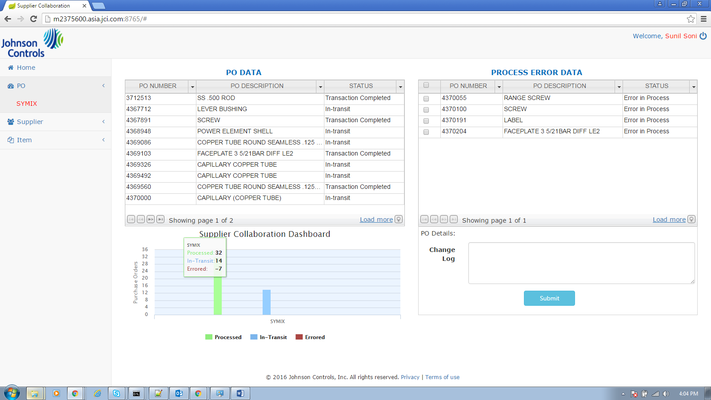

PO Grid without Process Error Grid (ErrorCount = 0)

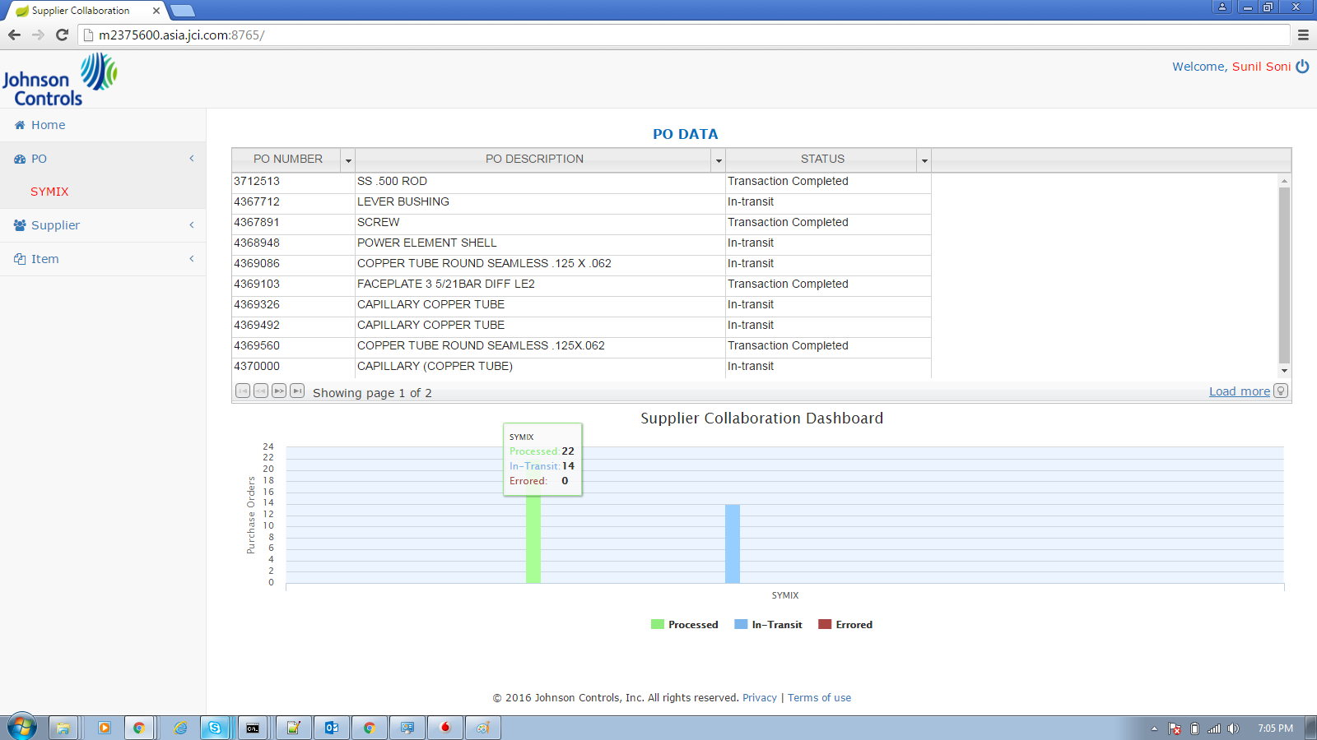

PO Details Grid (From Clicking on Po Number in PO Grid)

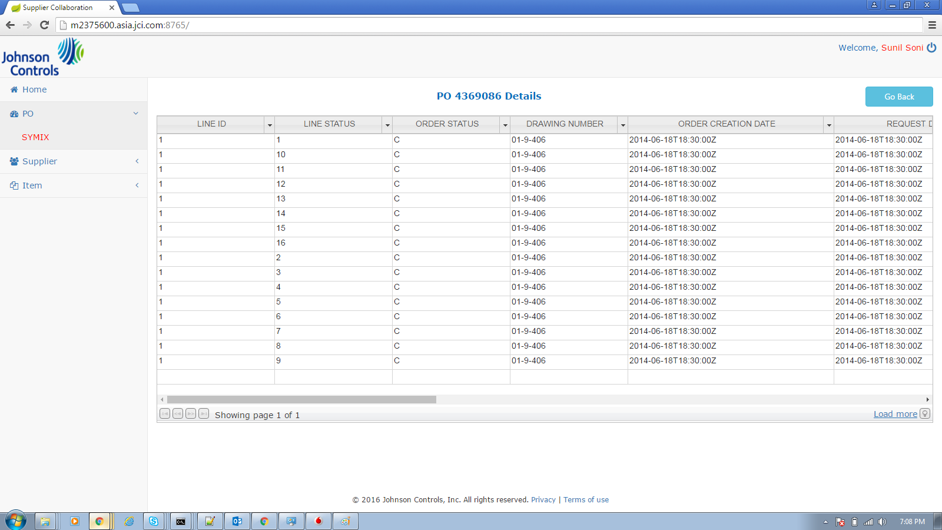

Supplier Grid

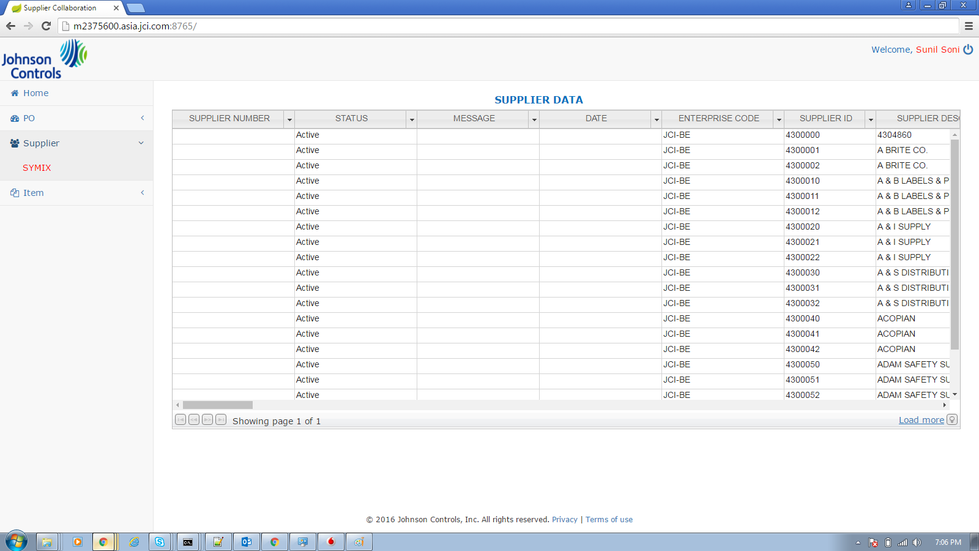

Item Grid

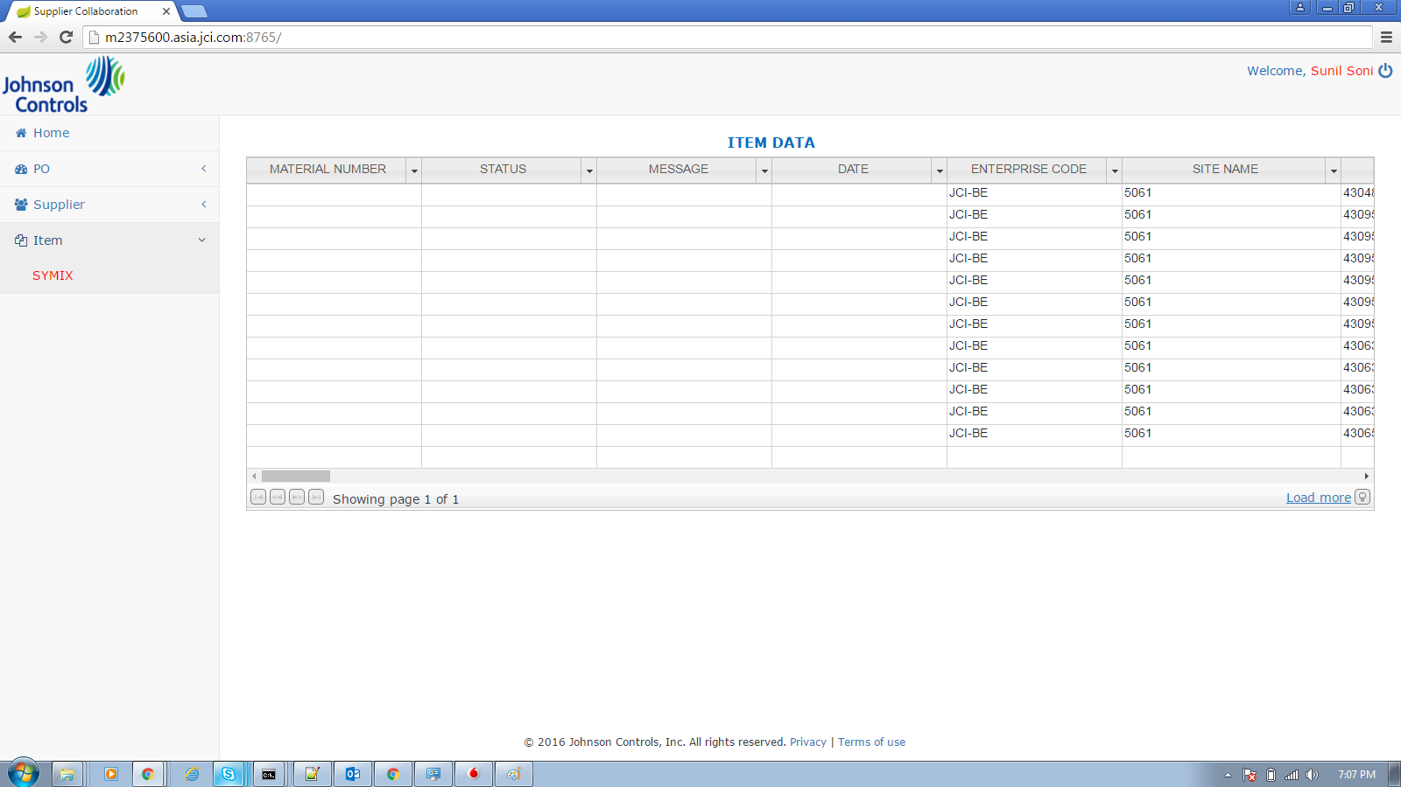

Windchill PLM

ECN Dashboard(Graph)

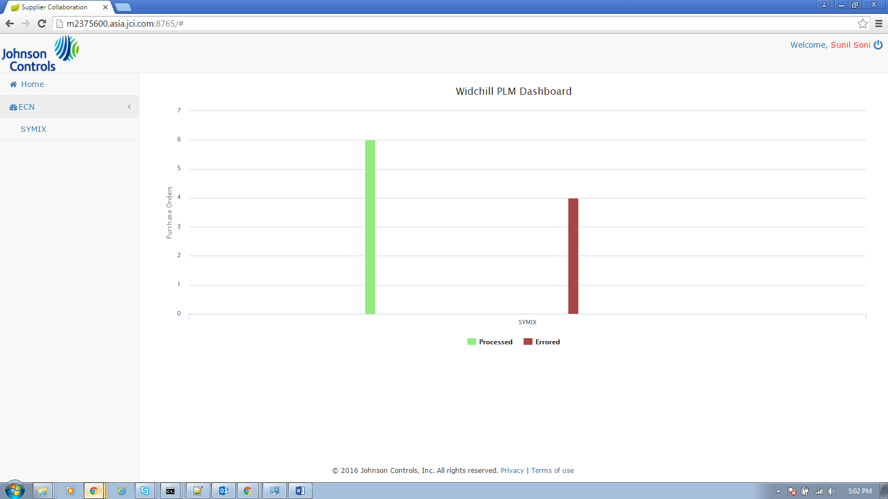

ECN Grid

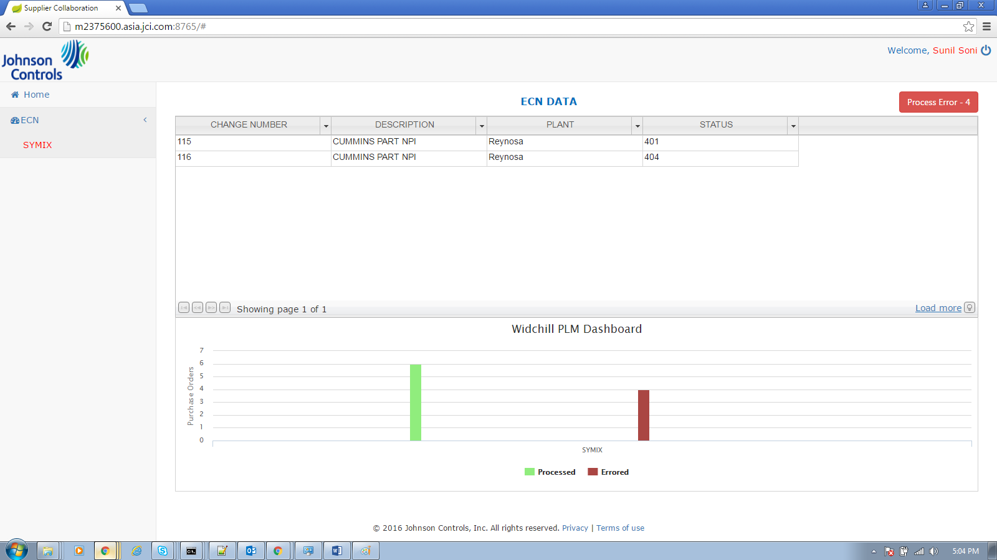

ECN Error Grid

